**Task # 1:** Write the same program with small variation i.e. this time the program will ask for 3 integers twice and displays the result for each addition separately;

Output will look like as follows:

Enter 3 integers for 1st addition

2

2

2

Enter 3 integers for 2nd addition

3

3

3

The sum of 1st addition is 6

The sum of 2nd addition is 9

**Code:**

.data

add1: .asciiz "Enter 3 Integers for 1st Addition \n"

add2: .asciiz "Enter 3 Integers for 2nd Addition \n"

out1: .asciiz "Sum of 1st Additon is: "

out2: .asciiz "\nSum of 2nd Addtion is: "

.text

la $a0,add1 #prompt on screen

li $v0,4

syscall

li $v0,5 #Input 1

syscall

move $t0,$v0

li $v0,5 #Input 2

syscall

move $t1,$v0

li $v0,5 #Input 3

syscall

move $t2,$v0

add $t3,$t1,$t0 #addition

add $t4,$t3,$t2 #additon of 1st 3 integers are stored in t4

la $a0,add2 #prompt for 2nd Addition Input

li $v0,4

syscall

li $v0,5 #Input 1

syscall

move $t0,$v0

li $v0,5 #Input 2

syscall

move $t1,$v0

li $v0,5 #Input 3

syscall

move $t2,$v0

add $t3,$t0,$t1

add $t5,$t2,$t3 #additon of next 3 Integers are stored in t5

la $a0,out1 #outPut Prompt

li $v0,4

syscall

move $a0,$t4

li $v0,1 #outPut result for 1st addition

syscall

la $a0,out2 #2nd output Prompt

li $v0,4

syscall

move $a0,$t5 # output result of 2nd addition

li $v0,1

syscall

li $v0,10 #program Terminate

syscall

**Output:**

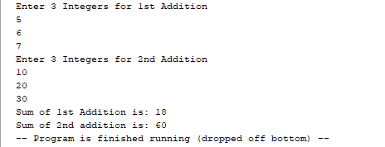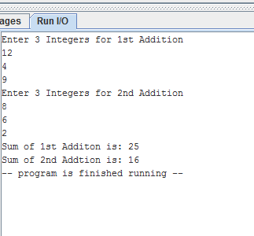

**Task # 2:** Write an assembly program that Multiply three number.

**Code:**

.data

In: .asciiz "Enter 3 Numbers for Multiplication: \n"

out: .asciiz "Multiplication is: "

.text

la $a0,In #Prompt

li $v0,4

syscall

li $v0,5 #Input 1st Integer

syscall

move $t0,$v0

li $v0,5 #Input 2nd Integer

syscall

move $t1,$v0

li $v0,5 #Input 3rd Integer

syscall

move $t2,$v0

mul $t3,$t0,$t1

mul $t4,$t3,$t2 #multiply and store in t4

la $a0,out #output prompt

li $v0,4

syscall

move $a0,$t4

li $v0,1 #output Resu;t

syscall

li $v0,10

syscall

**Output:**

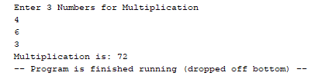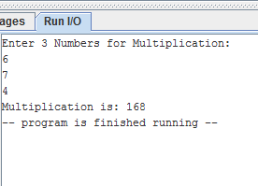

**Task # 3:** Write an assembly program that Divide two number.

**Code:**

.data

reminder: .asciiz"Reminder of 20 / 3 is: "

quotient: .asciiz"\nQuotient of 20 / 3 is: "

.text

li $t0,20 # hard coded value 1

li $t1,3 #hard coded value 2

div $t0,$t1

mfhi $t2 #Reminder

mflo $t3 #quotient

la $a0,reminder #prompt reminder

li $v0,4

syscall

move $a0,$t2

li $v0,1 #print Reminder

syscall

la $a0,quotient #prompt quotient

li $v0,4

syscall

move $a0,$t3

li $v0,1 #print Quotient

syscall

li $v0,10 #terminate Program

syscall

**Output:**

